**Signing into my class on ReadWorks:**

1. **Click ReadWorks**

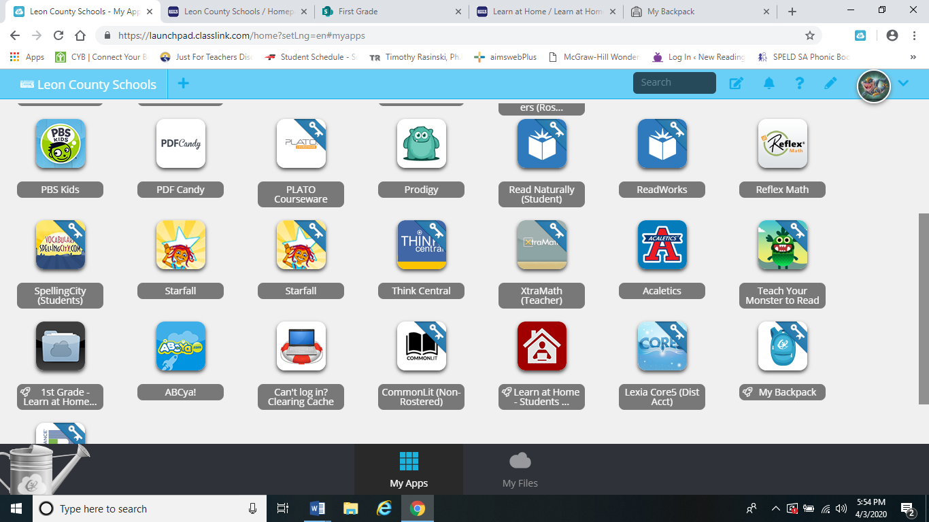

1. **Click Skip**

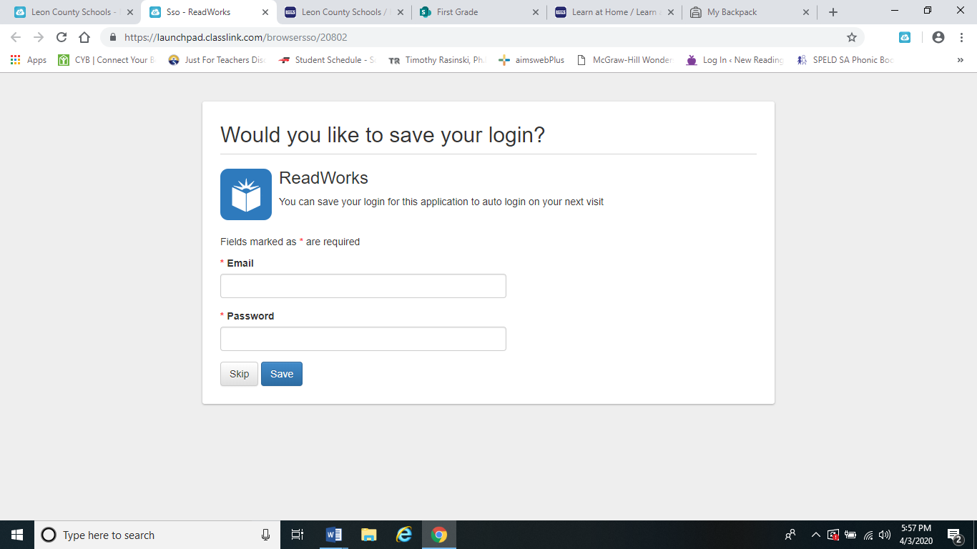

1. **Click Student Log In**

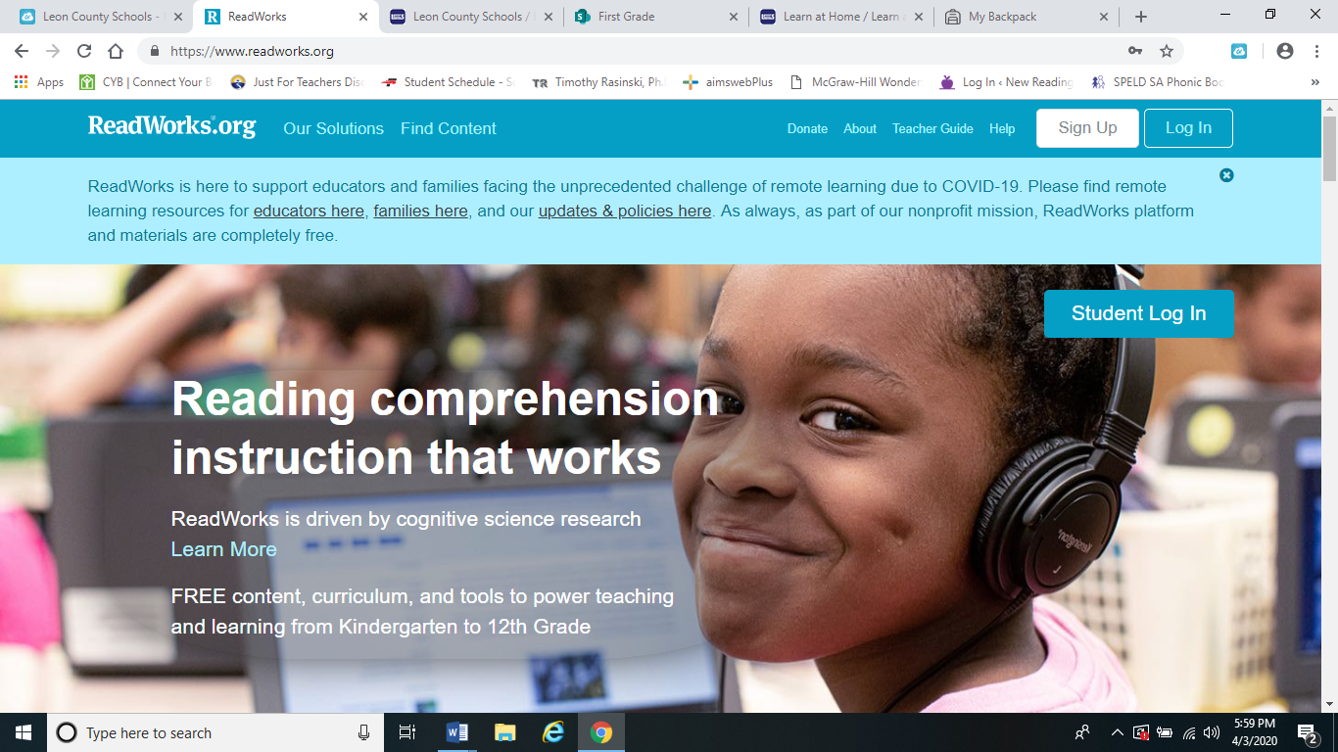

1. **Type Class Code: 3DUNKY**

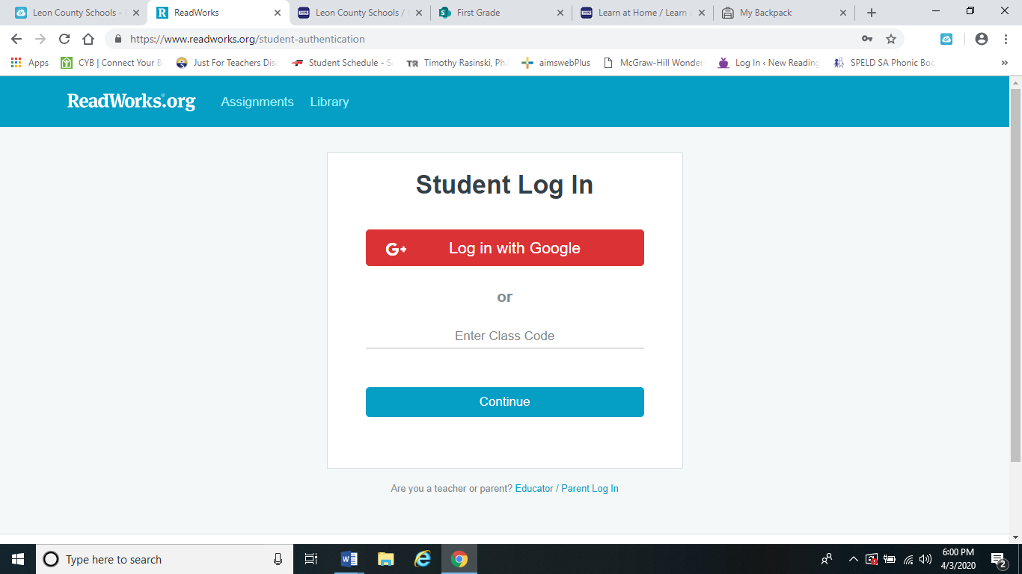

1. **Find your name in the list and click it.**

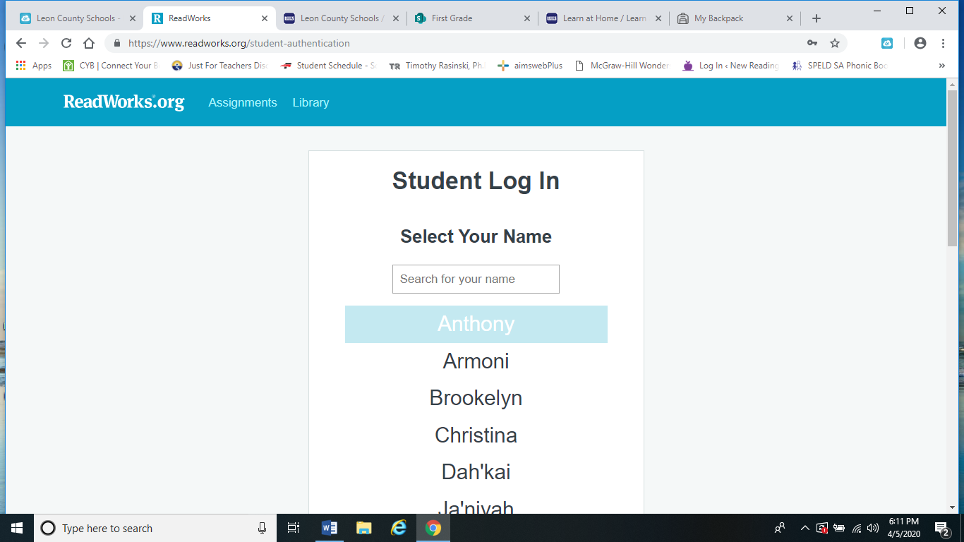

1. **Enter password: 1234**

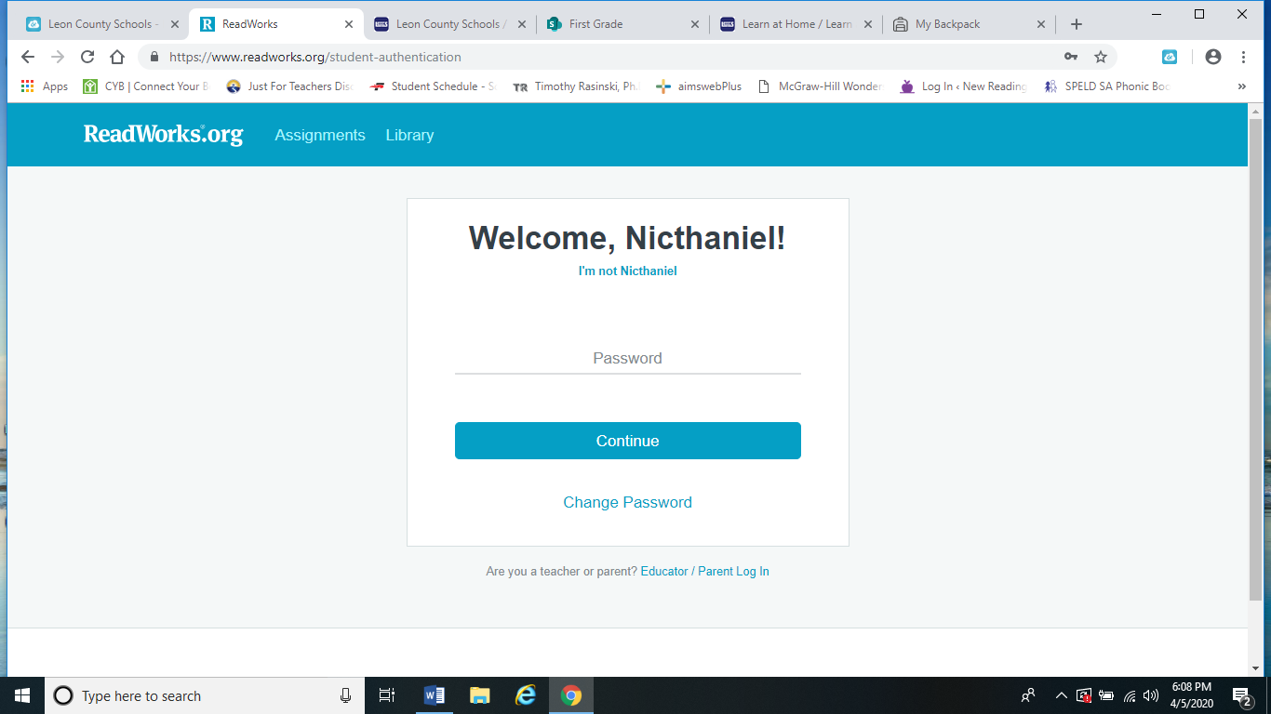

1. Assignments should appear

